Case for Support

School of Medicine’s Instructional and Simulation Lab at Orbach

The current space in the UCR School of Medicine Education Building that houses the Center for Simulated Patient Care is severely lacking and inadequate for student use. The educational space and equipment is insufficient for the current student enrollment and graduate medical education programs, as well as the planned future growth of the medical school. Presently, there are only 10 clinical skills rooms that are approximately 110 sq. ft. each. The rooms are scarcely able to fit five students with a faculty member and patient in each room. The simulation room is also small and there is only one usable space to run medical scenarios. The audio/visual equipment is antiquated and is in need of updating and replacement.

About this Word Template

To use this template, simply use it like any other Word document. To use the pre-set header formats, go to the “Home” tab and use the header options (photos below).

*Please remember to convert the full final file to PDF so there are no font discrepancies when this is forwarded to other computers that do not have this font.
Before beginning: You must install the TradeGothic No.20 Condensed font into your computer, and any other computer that you will use to edit this document. (A person from IT/help desk needs to give admin access to allow your computer to install this.)

What is Lorem Ipsum?
Lorem Ipsum is simply dummy text of the printing and typesetting industry. Lorem Ipsum has been the industry's standard dummy text ever since the 1500s, when an unknown printer took a galley of type and scrambled it to make a type specimen book. It has survived not only five centuries, but also the leap into electronic typesetting, remaining essentially unchanged. It was popularised in the 1960s with the release of Letraset sheets containing Lorem Ipsum passages, and more recently with desktop publishing software like Aldus PageMaker including versions of Lorem Ipsum.

Where does it come from?
Contrary to popular belief, Lorem Ipsum is not simply random text. It has roots in a piece of classical Latin literature from 45 BC, making it over 2000 years old. Richard McClintock, a Latin professor at Hampden-Sydney College in Virginia, looked up one of the more obscure Latin words, consectetur, from a Lorem Ipsum passage, and going through the cites of the word in classical literature, discovered the undoubtable source. Lorem Ipsum comes from sections 1.10.32 and 1.10.33 of "de Finibus Bonorum et Malorum" (The Extremes of Good and Evil) by Cicero, written in 45 BC. This book is a treatise on the theory of ethics, very popular during the Renaissance. The first line of Lorem Ipsum, "Lorem ipsum dolor sit amet...," comes from a line in section 1.10.32.

The standard chunk of Lorem Ipsum used since the 1500s is reproduced below for those interested. Sections 1.10.32 and 1.10.33 from "de Finibus Bonorum et Malorum" by Cicero are also reproduced in their exact original form, accompanied by English versions from the 1914 translation by H. Rackham.

Why do we use it?
It is a long established fact that a reader will be distracted by the readable content of a page when looking at its layout. The point of using Lorem Ipsum is that it has a more-or-less normal distribution of letters, as opposed to using 'Content here, content here', making it look like readable English. Many desktop publishing packages and web page editors now use Lorem Ipsum as their default model text, and a search for 'lorem ipsum' will uncover many web sites still in their infancy. Various versions have evolved over the years, sometimes by accident, sometimes on purpose (injected humour and the like).

University of California, Riverside School of Medicine
School of Medicine Education Building 900 University Avenue Riverside, CA 92521
(951) 236-0529 edna.yohannes@medsch.ucr.edu

Heading 1

Heading 2

Heading 3

Heading 4

Heading 5
Photo caption

Scroll down for instructions on how to use this template.

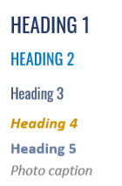
The headers above should look as they do in the image to the left. If they do not, the font is likely not installed to your computer.
Visit https://fonts.google.com/specimen/Oswald to download the font file. If you are using a UCR computer, you will likely need IT’s help to quickly install the font. Submit a ticket via the Helpdesk email.

Instructions

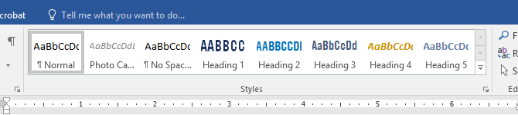

I have created pre-set header formats in the “HOME” tab of the toolbar within Microsoft Word (it will only be visible in this file). In the Styles section, you will see the section pictured above.

Simply highlight the text you want to change the formatting of, then use the Styles bar to click the heading setting that you want to use.

They are listed in order from largest to smallest, so Heading 1 should be used for the most major titles within the text, and Heading 5 for the lowest hierarchy of subheadings.
The photo caption setting should be used for all captions.

